**Q1. Program to ADD Two Numbers.**

**Code:**

dosseg

.model small

.stack 100h

.data

.code

main proc

mov bl,1

mov dl,2

add dl,bl

add dl,48

mov ah,2

int 21h

mov ah,4ch

int 21h

main endp

end main

**Output:**

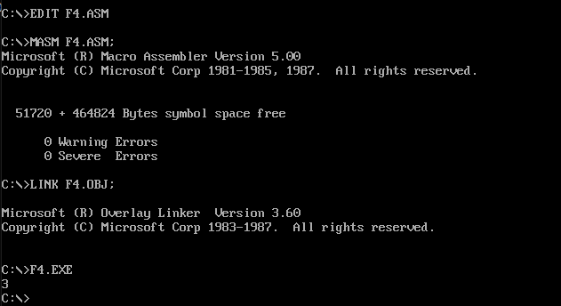

**Q2. Program to SUB Two Numbers.**

**Code:**

dosseg

.model small

.stack 100h

.data

.code

main proc

mov bl,4

mov dl,2

sub bl,dl

add dl,48

mov ah,2

int 21h

mov ah,4ch

int 21h

main endp

end main

**Output:**

